Jerusalem Maps & Demographics
Pre-1967 Jerusalem:  - Israel (West Jerusalem):  - 9,500 acres  - 150,000 Jews  - Jordan (East Jerusalem):  - 1,500 acres  - 9,000 Arabs |  | 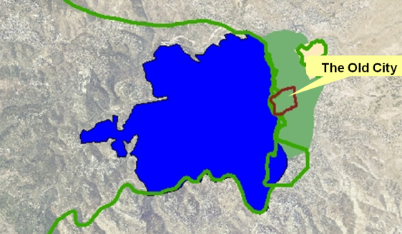
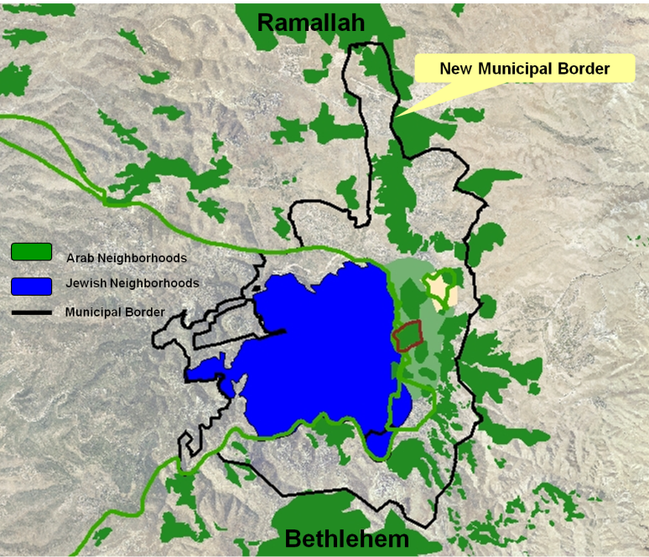 |  | Following the 1967 war, Israel annexed about 18,000 acres to Jerusalem, based on strategic and military considerations  28 Arab villages were annexed to Jerusalem.  Those Arabs got Israeli permanent residency and are eligible for full citizenship.
Jerusalem's Population, 1922-2008  Source: Jerusalem Statistical Yearbook, The Jerusalem Institute for Israel Studies, http://jiis.org/?cmd=statistic.296 | 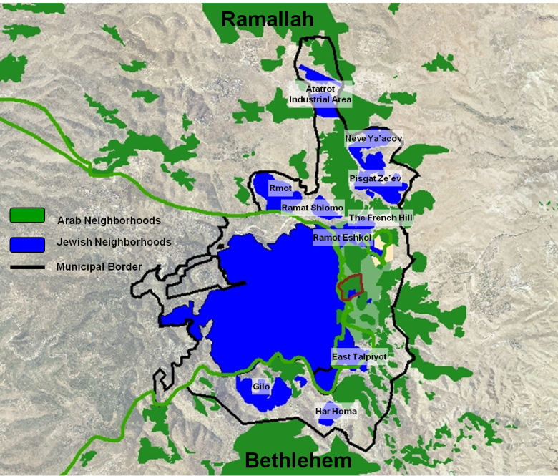  In 2010 there are 190,000 Israelis in East Jerusalem and over 250,000 Arabs.
  Year | Total  (000s) | Jews  (000s) | Arabs  (000s) | Jews  (%) | Arabs  (%)
  1922 | 62.5 | 33.9 | 28.6 | 54.3 | 45.7
  1931 | 92.9 | 53.6 | 39.3 | 57.7 | 42.3
  1967 | 266.3 | 197.7 | 68.6 | 74.2 | 25.8
  1983 | 428.7 | 306.3 | 122.4 | 71.4 | 28.6
  1992 | 556.5 | 401.0 | 155.5 | 72.1 | 27.9
  2000 | 657.5 | 448.8 | 208.7 | 68.3 | 31.7
  2005 | 719.9 | 475.1 | 244.8 | 66.0 | 34.0
  2008 | 763.6 | 495.0 | 268.6 | 64.8 | 35.2
Maps: www.peacenow.org.il

